Tricky five-in-a-row
This game is duo player who can play on a board consists of n x n fields. Players put their signs alternately (RED and BLUE) on the board. A sign can be put only into a free field (GREY).
The game ends, when the board is full, or a player won by having five adjacent signs in a row, column or diagonal. The program should show during the game who turns.
The trick in this variant is that if a player makes 3 adjacent signs (in a row, column or diagonal), then one of his signs is removed randomly (not necessary from this 3 signs). Similar happens, when the player makes 4 adjacent signs, but in this case two of his signs are removed.
Implement this game, and let the board size be selectable (6x6, 10x10, 14x14). The game should recognize if it is ended, and it has to show in a message box which player won (if the game is not ended with draw), and automatically begin a new game.

Ending condition:
- The board is full
- One of the players 5 adjacent signs in a row

Start menu:
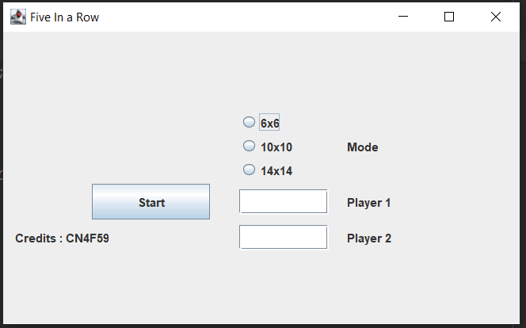

You have 3 modes to choose:
- 6x6
- 10x10
- 14x14